[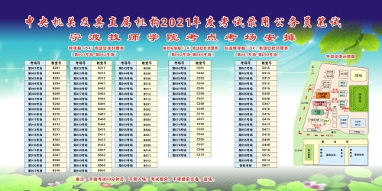](http://rsj.ningbo.gov.cn/picture/0/8d2c87715cb846488a8f26fb38b6efa4.jpg)